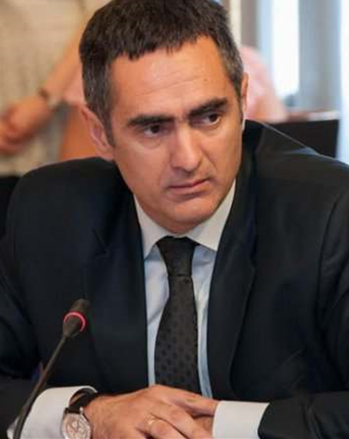

MSc Aleksandar Damjanović
Director
In Office
March,2021

